K4 Companion
macOS Installation from the Python Source

Please read and follow all steps carefully. These instructions have been verified on several Macs running macOS 15.5 and 26.5, and should work on other versions of macOS as well. The usual disclaimers apply: install at your own risk. Management, writers, producers, programmers, and all other associates are not responsible if you break your computer. Having said that, there is little to be broken, and there are no reports of any problems. This document assumes knowledge beyond that of a typical “appliance user.”
Commands are shown in a monospace font. Type each line in Terminal (Applications → Utilities → Terminal) and press Return after it.
Installing
- Install Apple’s Command Line Tools, which have the compiler that building Opus, and some Python packages, needs:
xcode-select --install
Click Install in the window that appears and accept the license. If they are already installed, the command says so. The full Xcode, from the App Store, works too, but its several gigabytes are not needed.
- Download and install the latest version of Python 3 from https://www.python.org/downloads, using the “macOS 64-bit universal2 installer.” Python 3.13 or later is needed: the encrypted connection to the K4, on port 9204, requires it. The Python 3.9 that comes with macOS is too old.
- Make a Python environment for K4 Companion, a folder named k4venv in your home folder, with its own python3 and pip:
/usr/local/bin/python3 -m venv ~/k4venv
/usr/local/bin/python3 is the Python just installed. The environment keeps K4 Companion’s packages apart from anything else, and works the same whichever shell Terminal uses, zsh or bash; no aliases or changes to .zshrc or .bash_profile are needed.
- Install the Python packages K4 Companion uses:
~/k4venv/bin/pip install numpy opuslib sounddevice pysocks pyyaml \
PyQt6 pyqtgraph python-rtmidi pyserial pyobjc-framework-Cocoa
sounddevice brings its own copy of the PortAudio audio library, so PortAudio does not have to be built. PyQt6 and pyqtgraph draw the user interface and the panadapter, python-rtmidi and pyserial connect MIDI and serial keying devices, and pyobjc-framework-Cocoa finds the folder where the settings are kept.
A K-Pod also needs hidapi; without it, the K-Pod tab says what to install:
~/k4venv/bin/pip install hidapi
- Build and install the Opus audio codec, which macOS does not include. Download the latest source release from https://opus-codec.org/downloads/ (opus-1.5.2.tar.gz at the time of writing); it will likely go to your Downloads folder. Then, with 1.5.2 replaced by the version downloaded:
cd ~/Downloads
tar xzf opus-1.5.2.tar.gz
cd opus-1.5.2
./configure
make
sudo make install
sudo asks for your password. The library is installed in /usr/local/lib, where K4 Companion finds it.
If you use Homebrew, brew install opus may be used instead: K4 Companion finds the library where Homebrew puts it.
- Download K4 Companion into a folder of its own:
mkdir ~/k4companion
cd ~/k4companion
curl -LO \
https://github.com/DaleFarnsworth/K4-Companion/raw/main/k4companion
Downloaded from the GitHub web page with a browser instead, the file is saved as k4companion.txt, and must be renamed k4companion. A k4companion.yaml file is no longer needed: the configuration is built into k4companion.
Running K4 Companion
Start K4 Companion from Terminal:
cd ~/k4companion
~/k4venv/bin/python3 k4companion
Leave the Terminal window open while K4 Companion runs: closing it stops the program. To be able to close it, start K4 Companion this way instead:
cd ~/k4companion
nohup ~/k4venv/bin/python3 k4companion >/dev/null 2>&1 &
If it stops with “ModuleNotFoundError: No module named …”, a package from step 4 is missing: install it with ~/k4venv/bin/pip install and the package’s name. Some modules’ names differ from their packages’: socks is pysocks, serial is pyserial, rtmidi is python-rtmidi, yaml is pyyaml, and AppKit is pyobjc-framework-Cocoa. If it stops because the Opus library cannot be found, see step 5.
To start K4 Companion from Finder or the Dock, make a K4 Companion.command file on the Desktop:
cat > ~/Desktop/'K4 Companion.command' <<'EOF'
#!/bin/sh
cd ~/k4companion && exec ~/k4venv/bin/python3 k4companion
EOF
chmod +x ~/Desktop/'K4 Companion.command'
Double-clicking it opens a Terminal window in which K4 Companion runs. It may be moved anywhere, or dragged to the Dock.
The First Start
Enter the radio’s information in the Server tab and press Connect. K4 Companion connects on the K4’s encrypted port, 9204, so no port needs to be entered.
The first time, macOS asks for two permissions, for Terminal, the application K4 Companion was started from:
- Local network access (macOS 15 and later): click Allow. The connection fails while macOS asks, so press Connect again after allowing it.
- Microphone access: click Allow. Without it, K4 Companion cannot send the computer’s microphone audio to the K4.
If either was refused, turn Terminal on in System Settings → Privacy & Security → Local Network, or → Microphone, then quit and restart K4 Companion.
Building a Mac App (Optional)
To start K4 Companion from Applications like any other app, without Terminal, K4 Companion.app may be built from the full repository with PyInstaller, the way the project builds it. git comes with the Command Line Tools:
cd ~
git clone https://github.com/DaleFarnsworth/K4-Companion.git
cd K4-Companion
~/k4venv/bin/pip install pyinstaller pillow
~/k4venv/bin/python3 tools/add_data_variable -i k4companion \
-o k4companion.py example_config_files/k4companion.yaml
OPUS_DYLIB=/usr/local/lib/libopus.dylib \
~/k4venv/bin/pyinstaller --noconfirm tools/k4companion.spec
With Opus from Homebrew, use OPUS_DYLIB=$(brew --prefix opus)/lib/libopus.dylib instead. The add_data_variable command builds the configuration into the program, as k4companion has it. The app, which carries its own Python and Opus, is then in the dist folder; drag it to Applications. It asks for the local network and microphone permissions itself, rather than for Terminal.
An App Store version of K4 Companion will not be made available, due to Apple’s licensing requirements.
Using RUMlogNG Alongside K4 Companion
RUMlogNG is a free (and excellent!) logging program for macOS, by Thomas Linder, DL2RUM, available from the App Store. The two programs run perfectly side by side. Connect RUMlogNG by TCP, with manufacturer Elecraft and type K4-Ctrl, to the radio’s address and port 9200, as on its configuration page below.

Settings for running side by side with K4 Companion
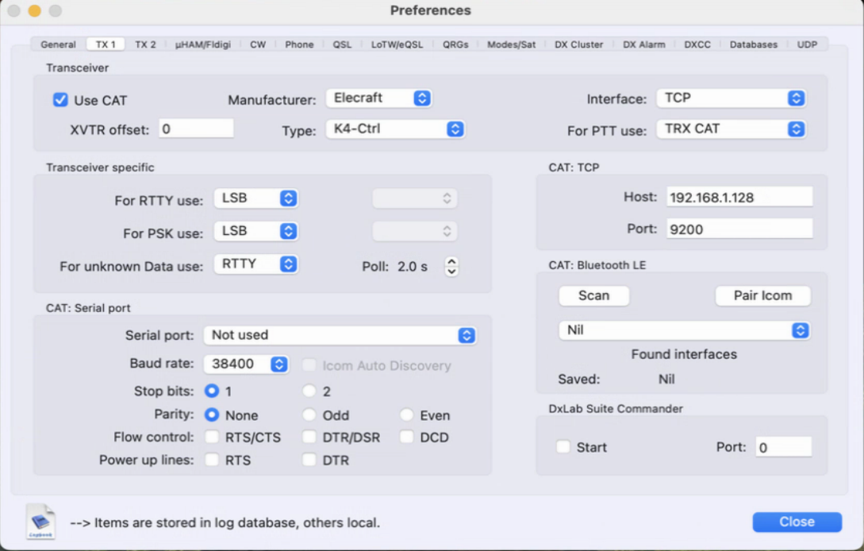
Image used with permission, Thomas Linder, DL2RUM

Revised 5 October 2026

